
Volunteer Application Pack

Thank you for taking an interest in becoming a Volunteer with SOS NI.

This Application Pack provides you with all the information you need to decide whether SOS is that right charity for you. If you have any questions at all you can contact the SOS Office on 02890 664505.

Once you have read through all the information included in the application pack and if you decide you would like to proceed, please fill out the attached Volunteer Registration Form and forward to
caitlin@sosbusni.com or post to the following address -

SOS NI
Office 13
Building 7
Weavers Business Park
Linfield Road
Belfast
BT12 5GH

What is SOS Bus NI?

Since 2007, SOS NI has worked in partnership with the emergency services, voluntary organisations, and other statutory organisations every weekend in Belfast. In doing so, we create a safer city for everybody during the busy night-time economy. SOS NI is a recognised Safe Haven at which everybody is warmly received without prejudice or judgement. For those who need emotional and/or physical help, the SOS team provide professional caring and medical support.

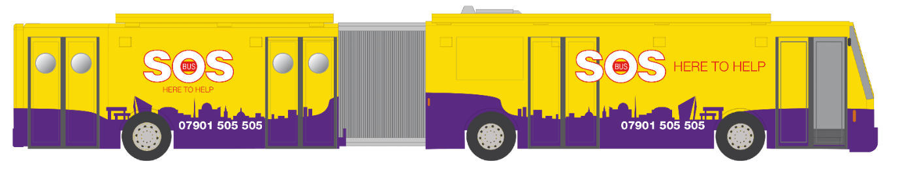

SOS NI boasts a fleet of specially designed vehicles consisting of our Community Bus and 2 x SOS Response Mini-buses. The Community Buses are parked in Belfast City Centre and are a Safe Space for anyone vulnerable or in need. They are supported by SOS Response Teams, working on-board the SOS Mini-buses.
Our dedicated SOS Volunteers support clients from all different backgrounds who present with a range of different issues which can include -

- Major/ minor accidental injury
- Drunkenness and over indulgence of alcohol and/or drugs
- Homelessness
- Victims of violent crime
- Isolated, lost or separated from friends
- Depression, Suicide or other serious Mental Health issues

SOS Volunteers are provided with all training needed to provide exceptional care to our clients, including Sign-posting Awareness, which trains Volunteers and provides a directory of support services in Northern Ireland that clients can be made aware of and encouraged to contact, in the hopes they can access aftercare.

The presence of SOS on the streets eases pressure on the PSNI, emergency departments, ambulance services and Belfast City Council.

Volunteer Opportunities

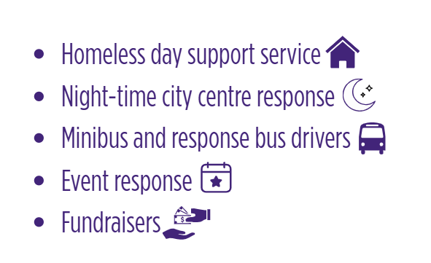
It is only through the wonderful generosity of our 140 trained SOS Volunteers that we can continue to provide our essential services to people in Belfast. SOS NI is a Volunteer led organisation with training and skill based learning at the centre – we fervently believe in building our Volunteers life skills and confidence within the organisation and outside.

No matter which SOS Programme(s) you choose to donate your time to, you can be assured that your contribution will be highly valued and appreciated.

Night-time Services Volunteer

SOS Volunteers who work on our night-time services are asked to donate 4 x hours per month, working as part of an experienced team on one evening shift.

All new Volunteers are immediately placed into a probationary period, during which you will go through the application process that involves several stages –
- attending a New Volunteer Interview
- completing 3-5 buddied shifts on-board the SOS Buses
- completing all compulsory training courses provided by SOS

Once you have completed all stages of your application, you will be involved in a shared review of your performance along with the Volunteer Coordinator. If you pass your review, you will then be asked to join and Core Team and will be presented with an SOS Jacket.

- The minimum age requirement for individuals volunteering on the SOS Bus during a night-time shift is 18 years.

Mini-bus Drivers

SOS Mini-bus Drivers is a popular volunteer role. Driver are required across all SOS Programmes including Night-time Services, Food Programme and our Transport Programme. Hours of volunteering across the Food and Transport Programmes are scheduled both during the day and then evening.

- Requirements to become and SOS Driver -
You must be at least 25 years old
You must have had a full driving license for at least 2 years
You must have less than 3 points on your current license

You do not need any past experience to get involved in the driving of the mini-buses. We are happy to provide any training and pay for driving assessment with a training company.

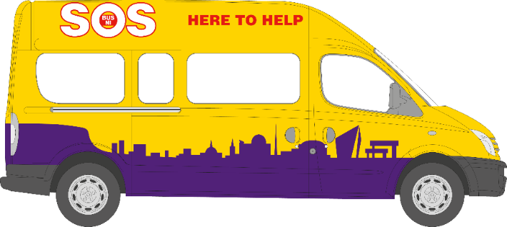

Daytime Services Volunteer

Every Monday to Friday from 2 – 6pm, a team of 2-4 experienced volunteersprovide welfare to those in need in the City Centre. This programme is mainly targeted towards those experiencing homelessness, where volunteers provide first aid, provisions and support.

- The minimum age requirement for individuals volunteering on the SOS Bus during a day-time shift is 18 years.

Queen’s University Get Home Safe Programme

In partnership with Queen’s University, SOS offer a shuttle service every Wednesday and Thursday night from 12am – 2 am. This is in response to a spike in racist and sexist attacks on students as they walked home from City Centre to their student accommodation. Leaving from Kremlin and Limelight, SOS minibuses transport any vulnerable students.

Queen’s University Safe Space Programme

Also in partnership with Queen’s University, SOS offer a Safe Space programme at McClay Library every Tuesday 7 – 10 pm. Here, we offer provisions such as tea and coffee and a safe space for students to chat with our experienced volunteers.

Training Opportunities

We acknowledge that it is the outstanding and professional care provided by our Volunteers that has ensured that SOS has become a recognised and trusted organisation in Belfast and beyond. In return for your time and commitment, we wish to invest in your future and are committed to your personal development during your time here at SOS. One way we do this is through Core and Accredited Training courses. All courses are provided free of charge; it is our gift to you.

Core Training

All Volunteers must complete 4 mandatory training courses -

- SOS Induction Evening
- Essential Listening Skills
- Basic Life Support
- Zero Suicide Alliance Training

We are delighted to be able to offer Volunteers a range of training opportunities, both compulsory and optional, to increase their skill set and personal development.

Examples of training we offer –

- Conflict Resolution
- Substance misuse in the Homeless Community
- Safe Administration of Naloxone
- Safe-guarding Vulnerable Adults & Children
- Drugs Awareness
- PSNI Training (Human Trafficking Unit, Rape Crisis Unit)

